Repositories Assessments
Individual Assessments

GitHub

1. Create a remote repository:

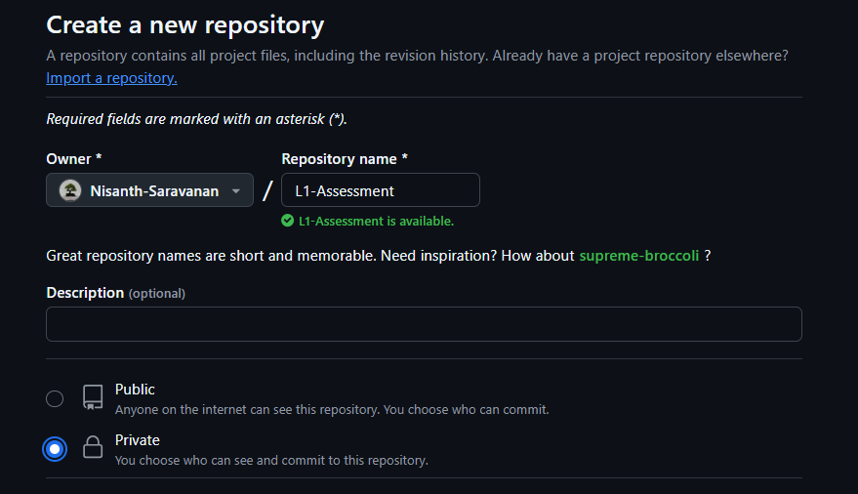

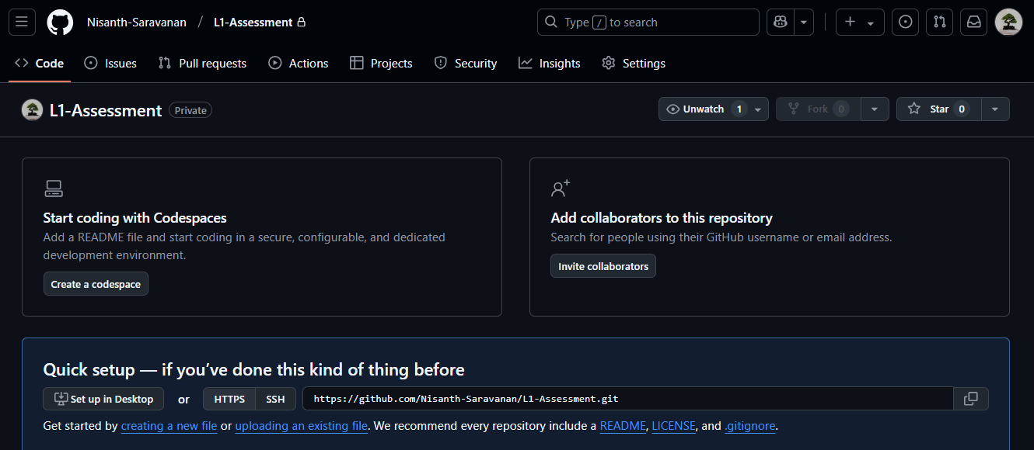

2. Clone the Repository:

3. Simple directory and file creation:

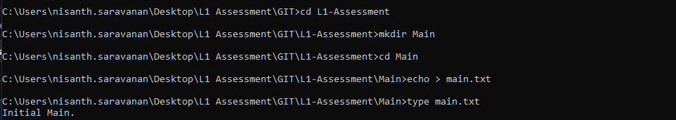

4. Staging and Local Commit:

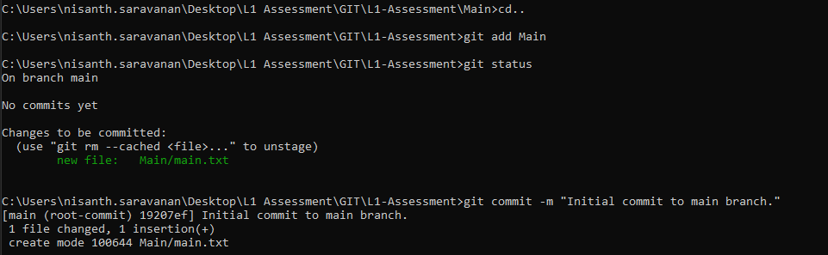

5. Pushing changes to remote:

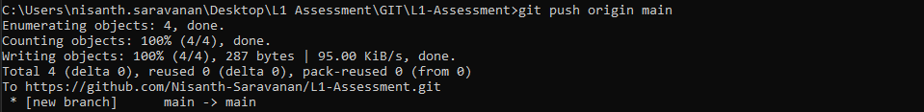

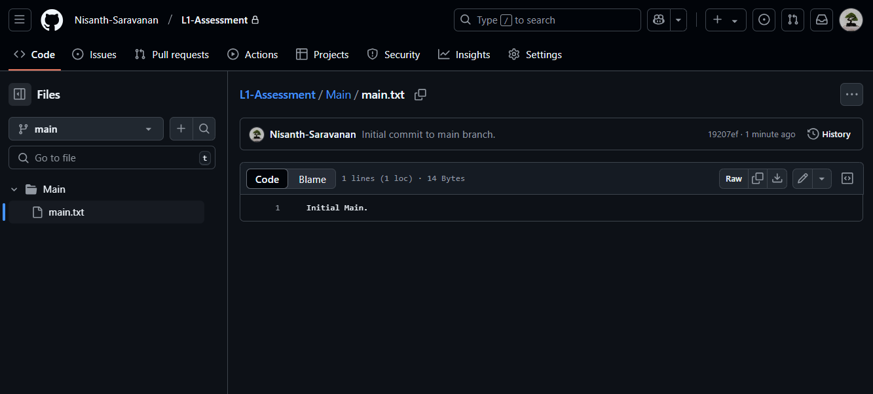

6. Pulling Changes:

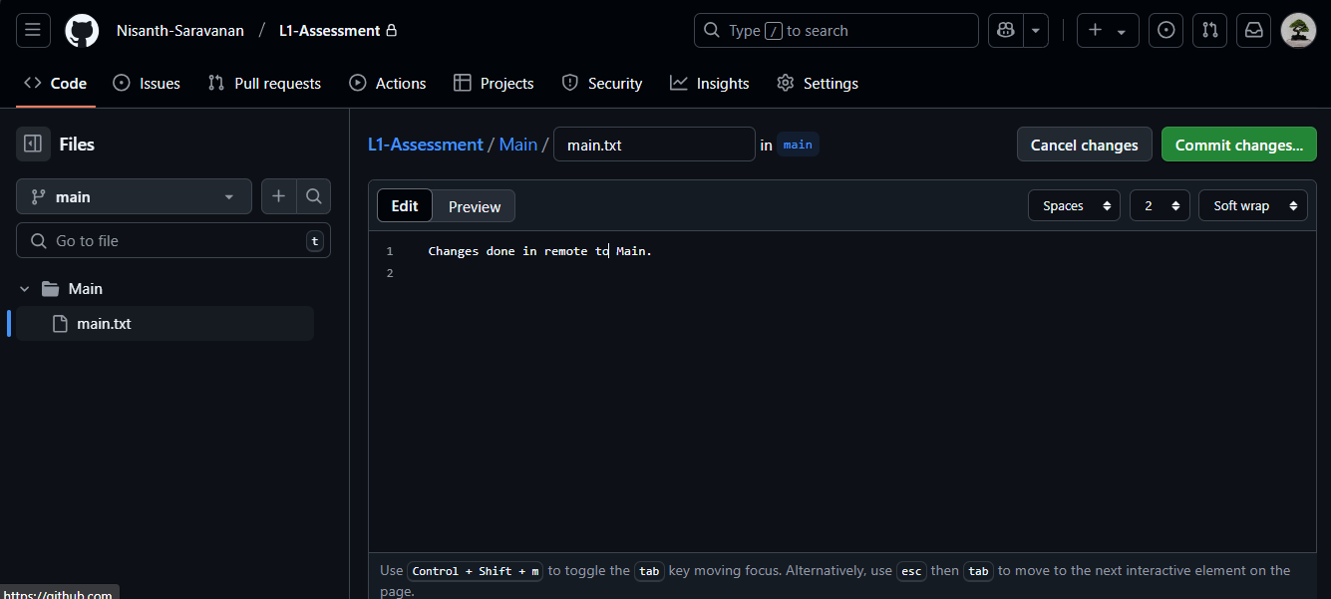

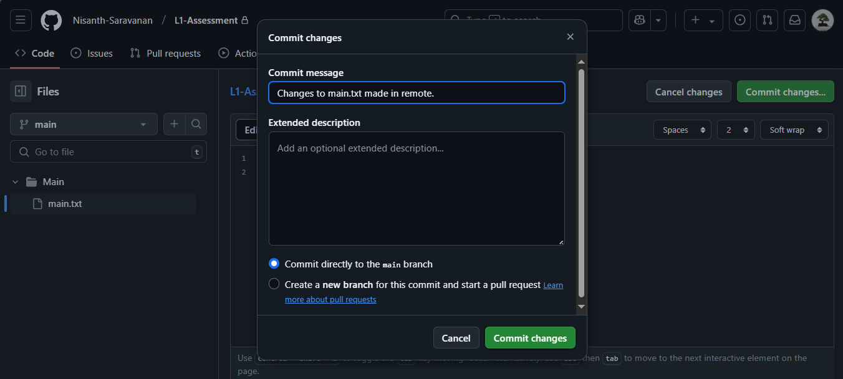

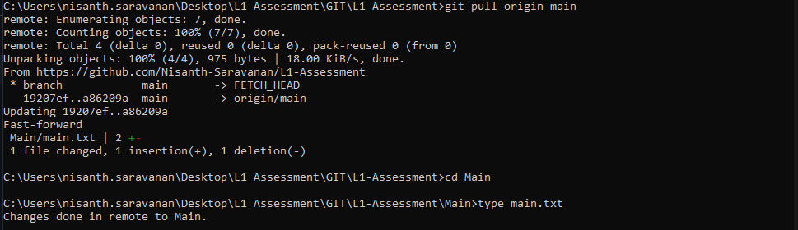

Note: type <filename> is used to display the contents of the file, and the contents of the main.txt file has been modified successfully in the local repository.
7. Creating and switching to new branch:

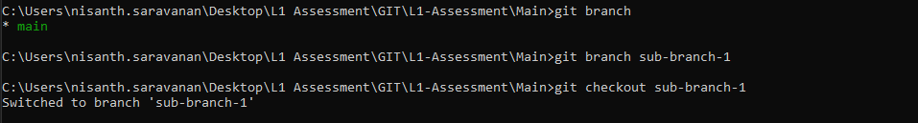

6. Creating files and pushing files to branch:

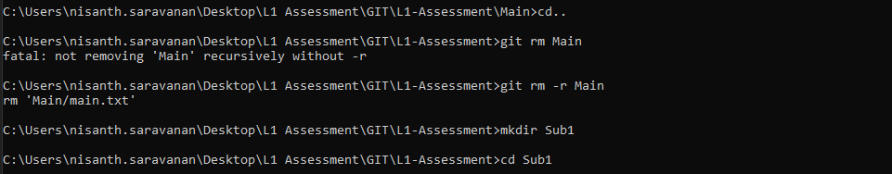

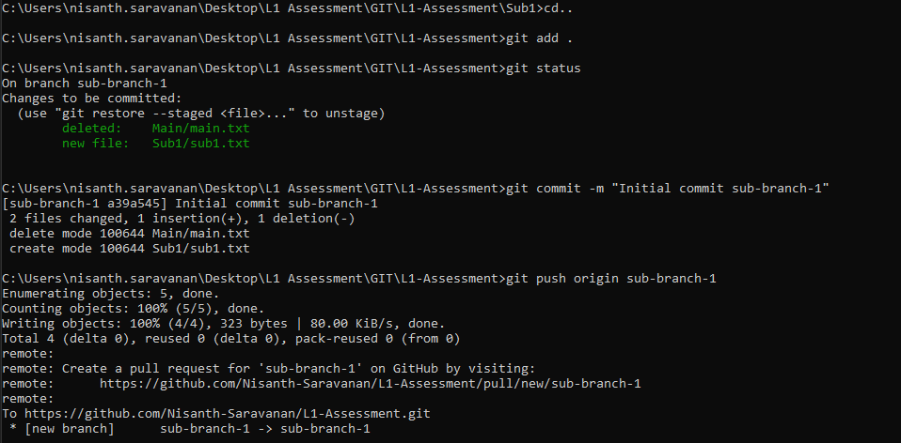

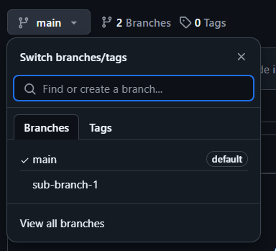

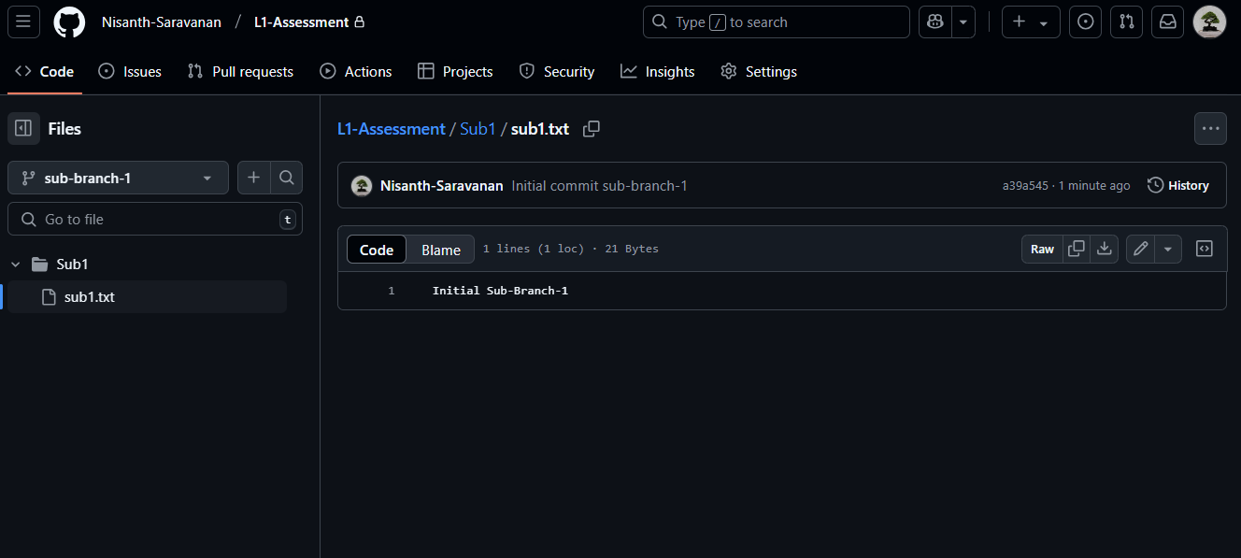

5. Conflict Resolution: Changing Remote:

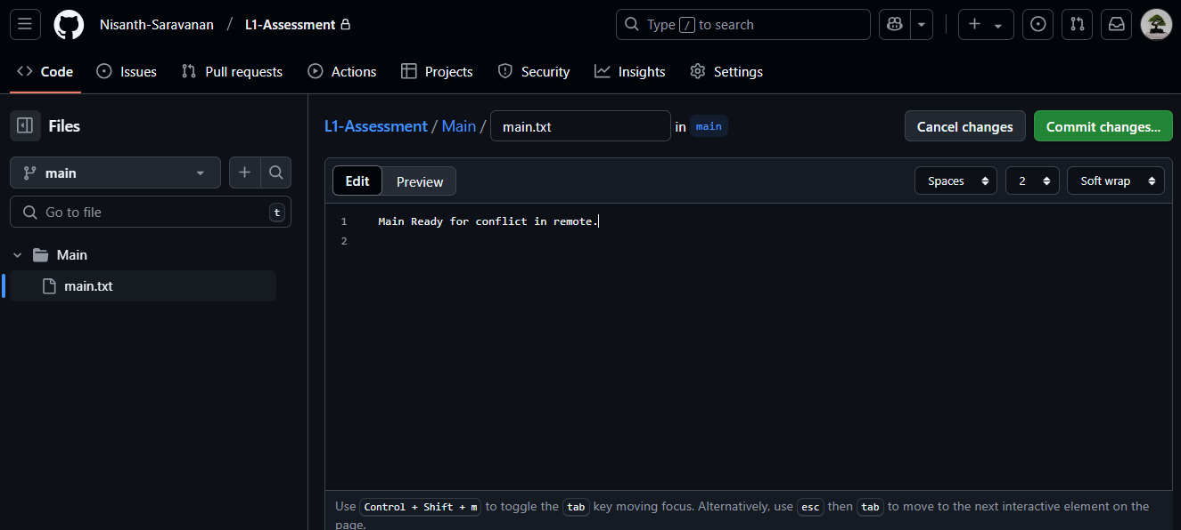

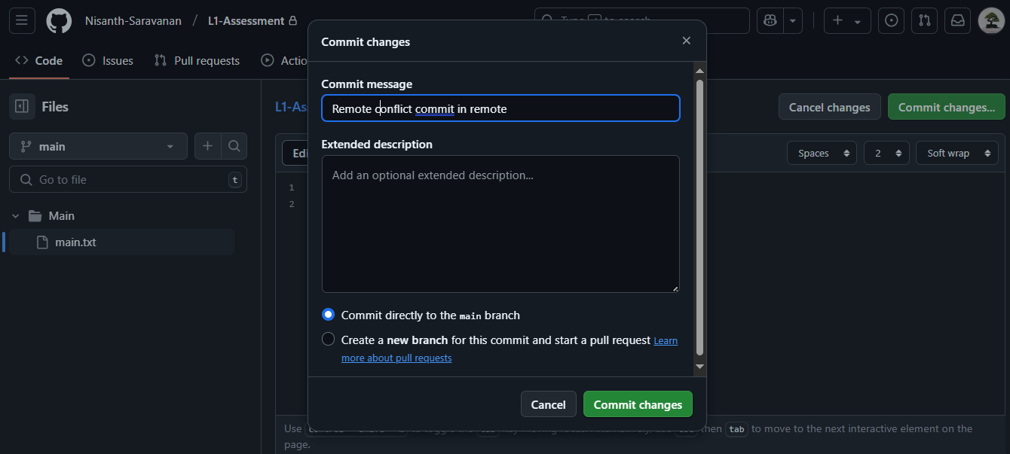

Changing Local:

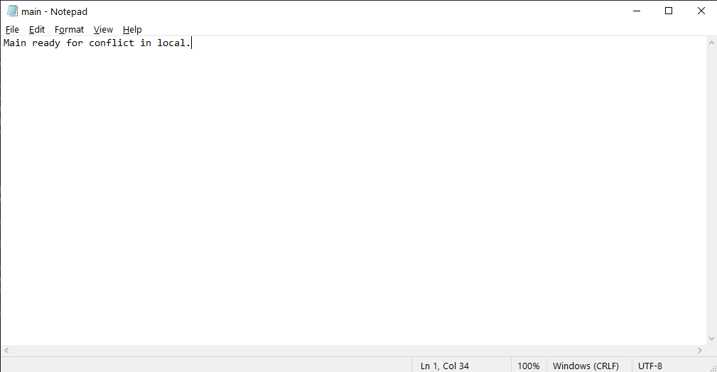

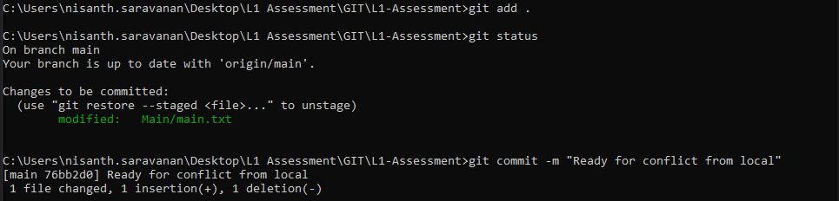

Pulling and merging the conflicted files:

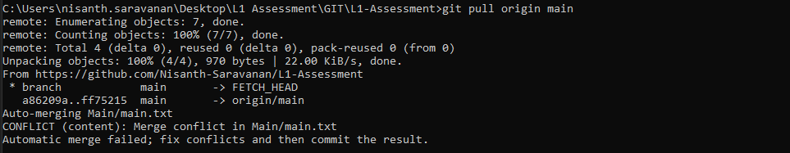

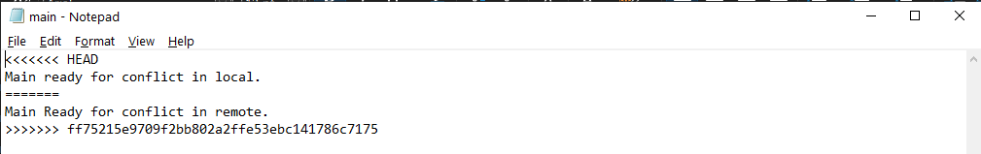

Accepting changes from remote and committing:

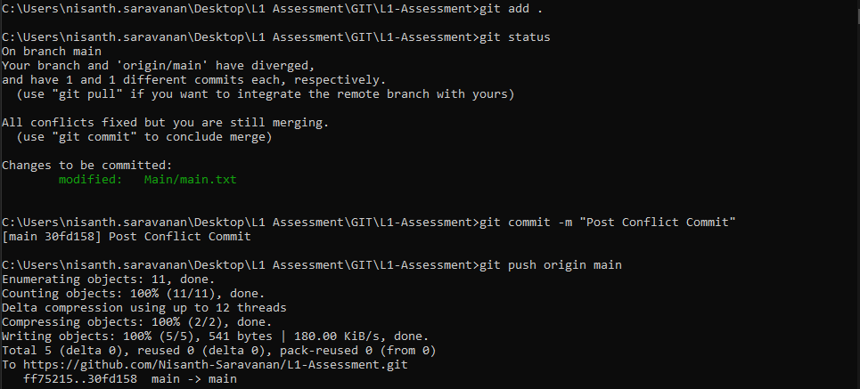

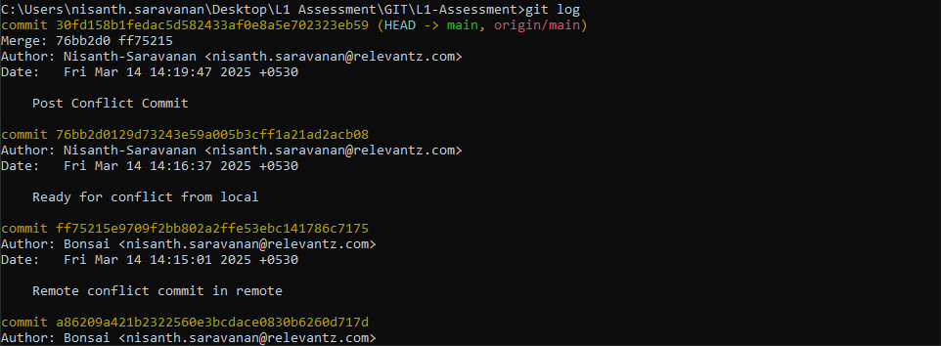
6. Pull requests:

Initial state of the remote repository:

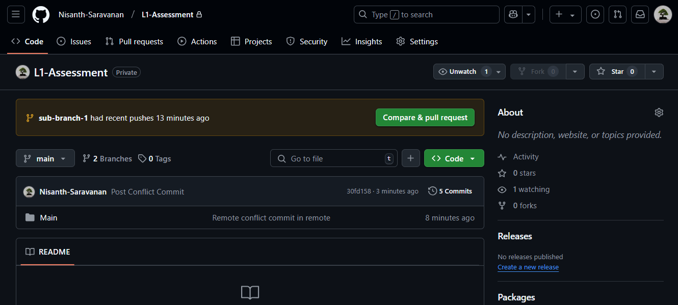

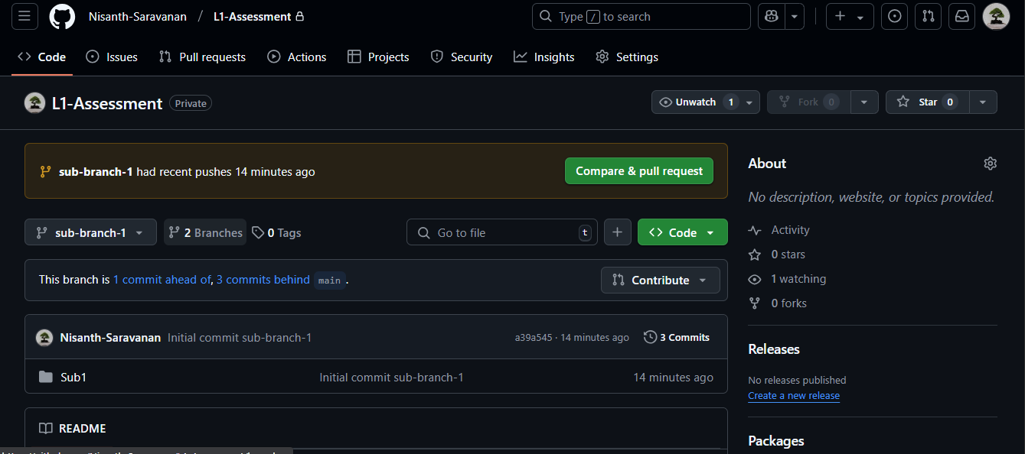

Creating a pull request:

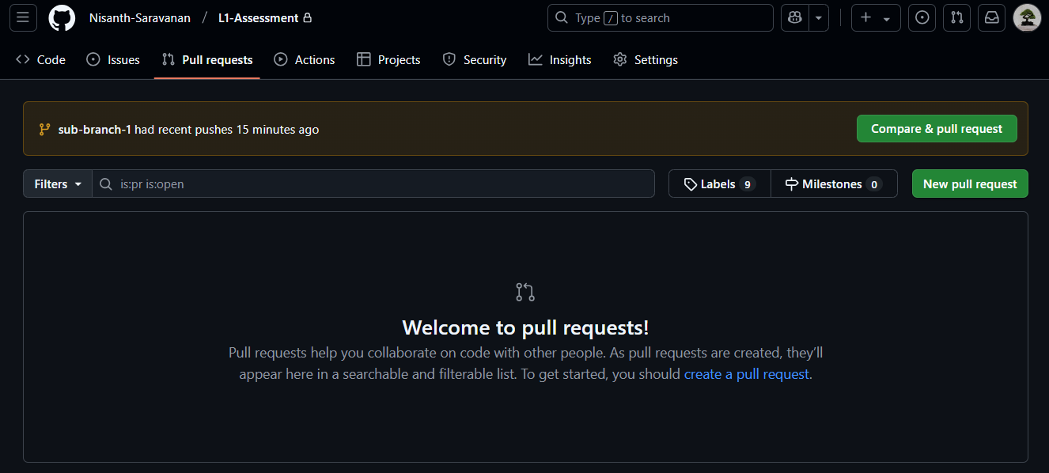

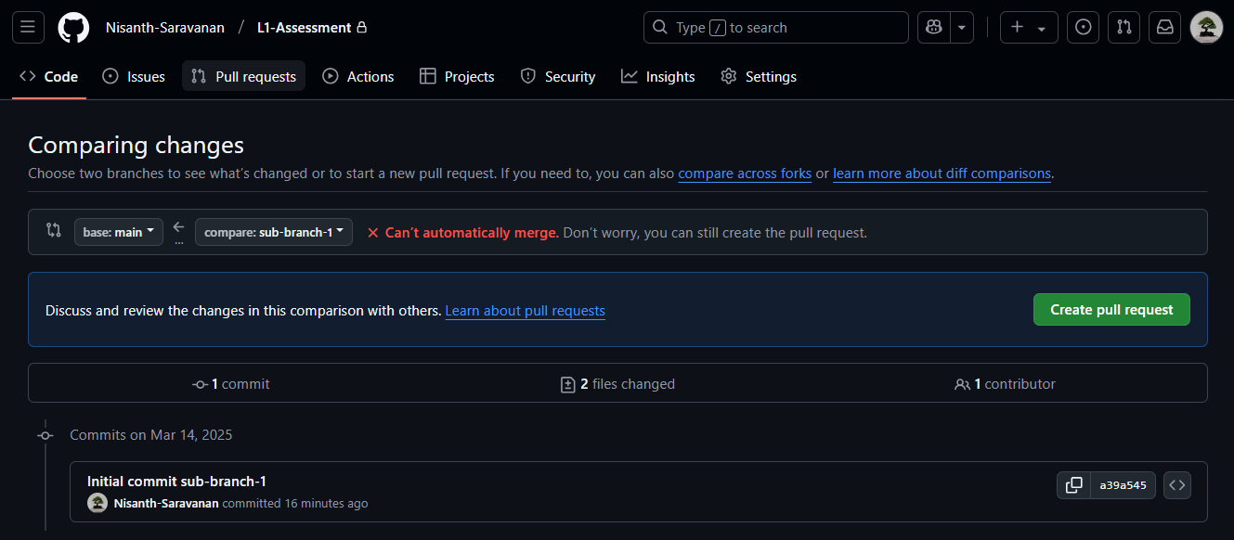

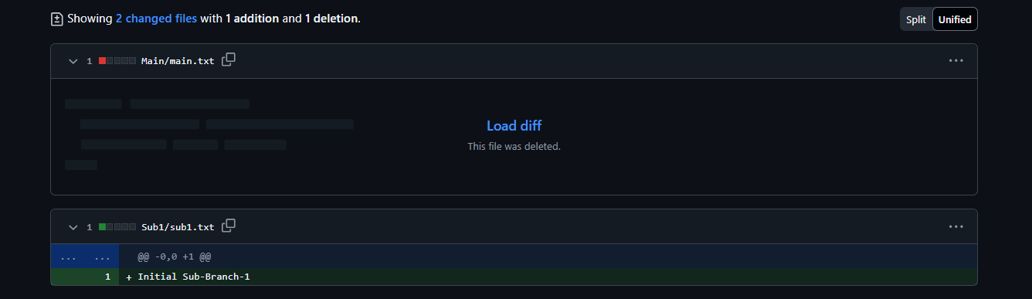

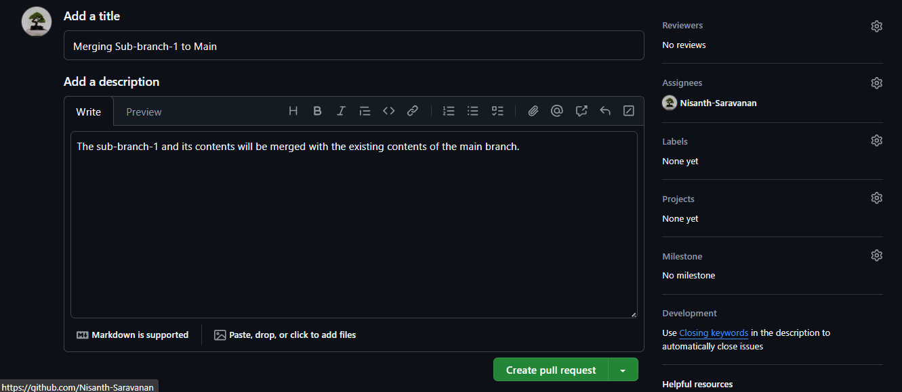

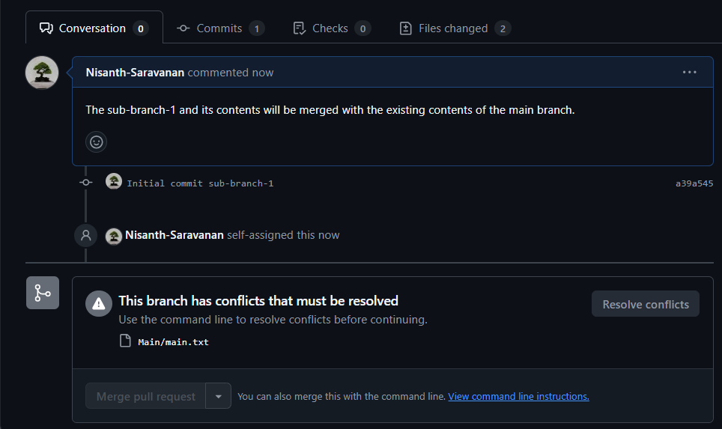

As the merging can not be done automatically, it is advised to make use of the command-line interface for merging:

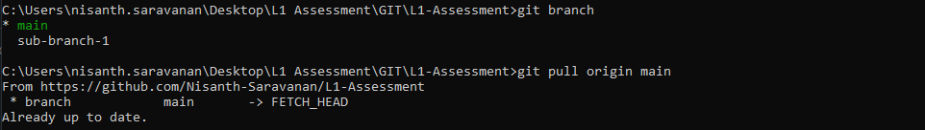

Merging in cmd – with main as base and sub-branch as compare:

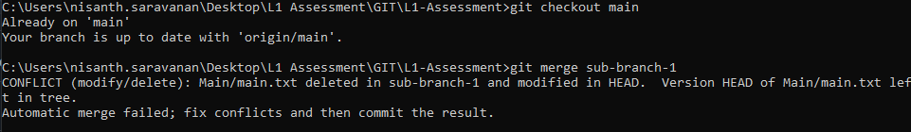

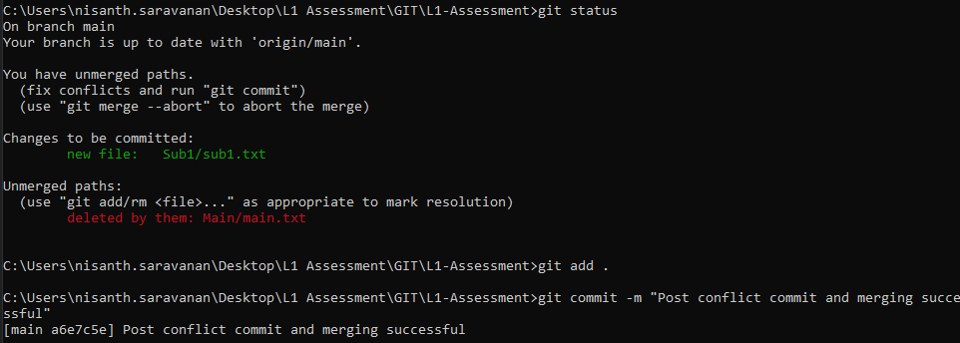

Pushing changes after merging the branch:

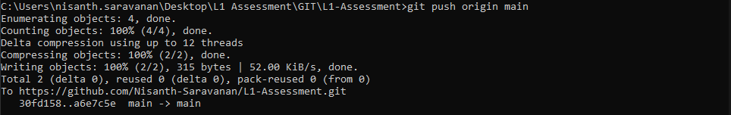

Final view of local repository:

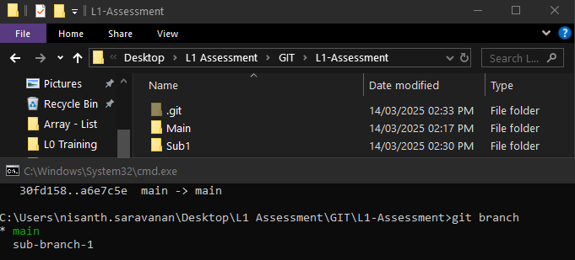
Final view of the remote repository:

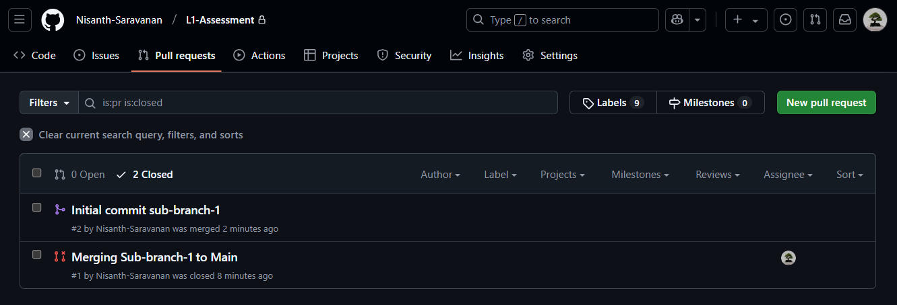

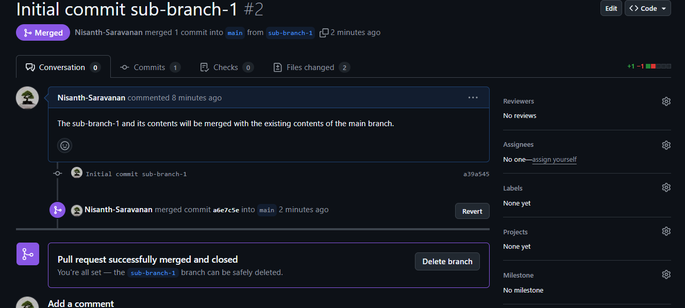

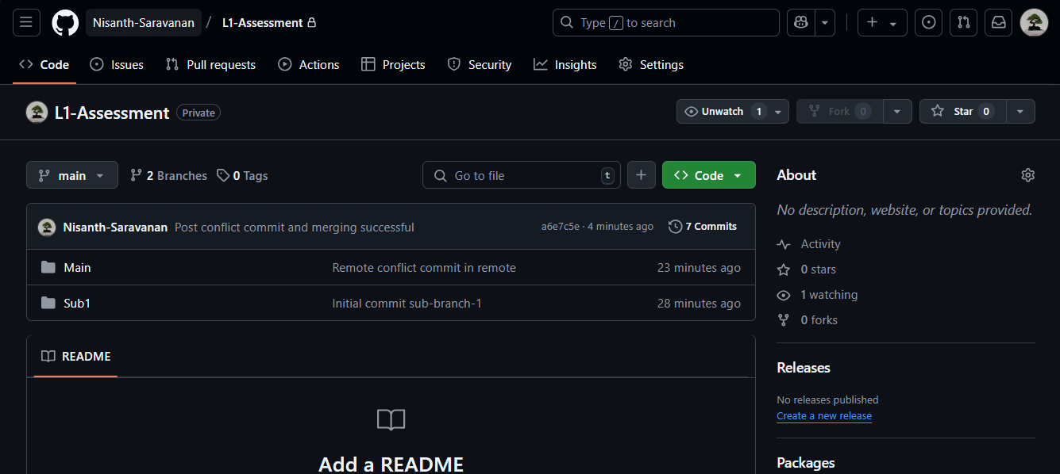
7. Tags:

Creation, listing and pushing under a specific tag:

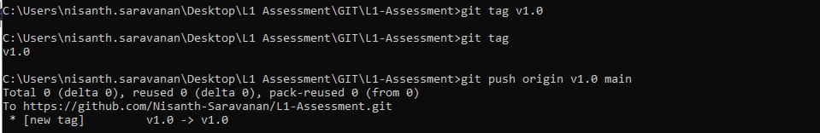

Reflection in remote:

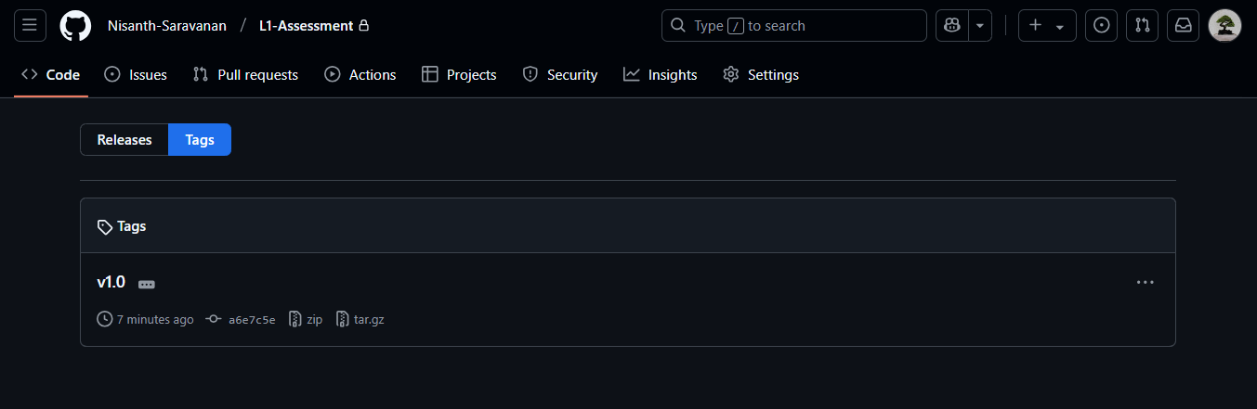

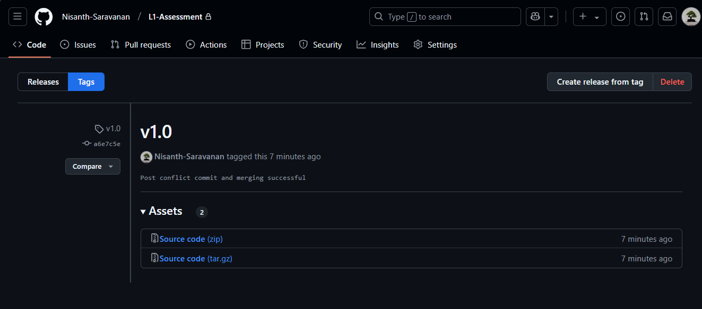
8. Deleting a branch after pull request: locally and globally:

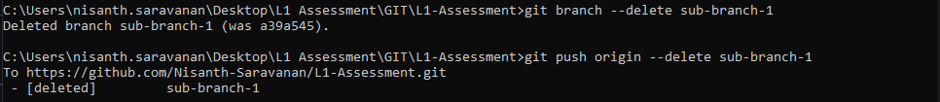

Reflection:

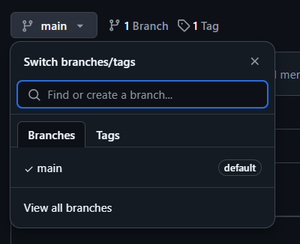
BitBucket

1. Creating a new repository:

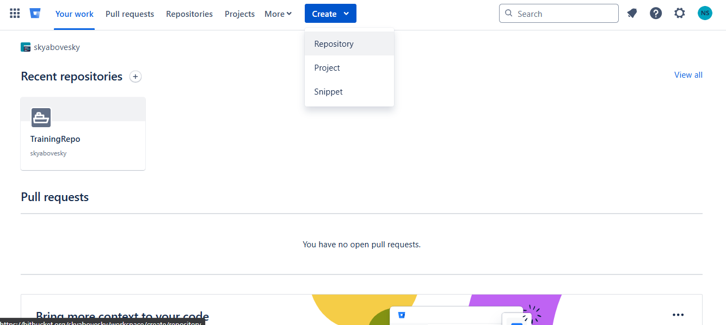

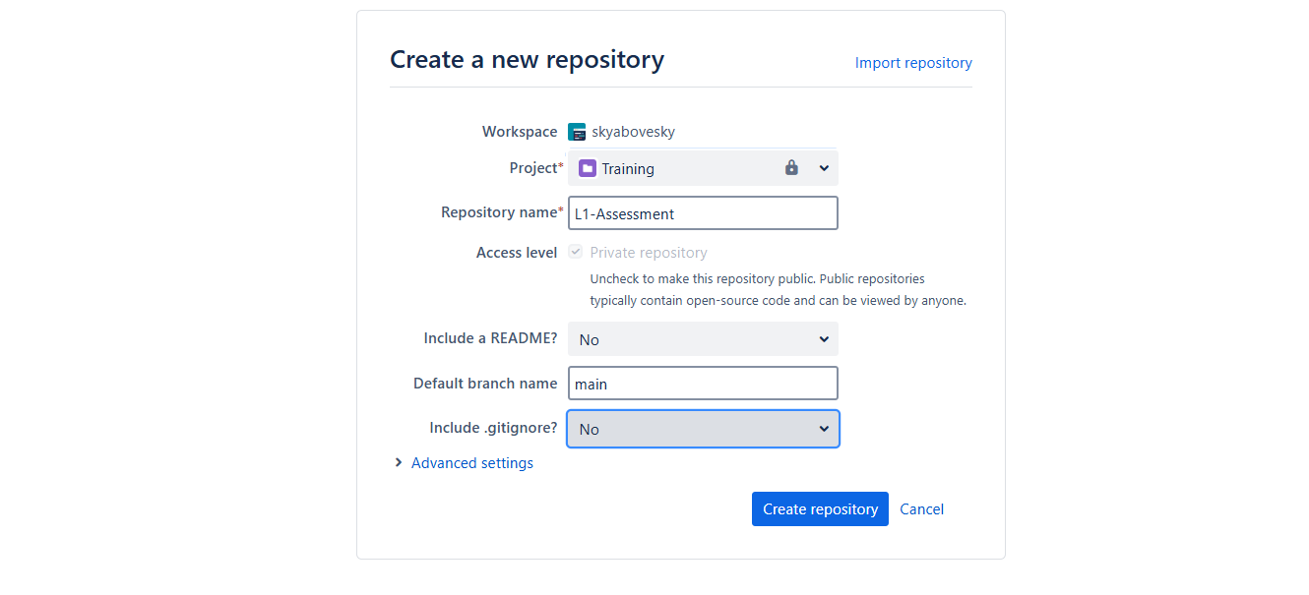

2. Clone repository:

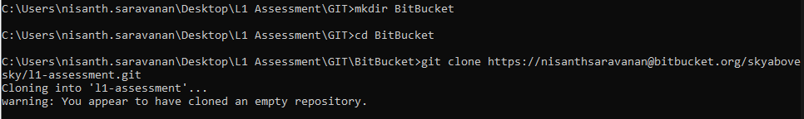

3. Local staging and commits:

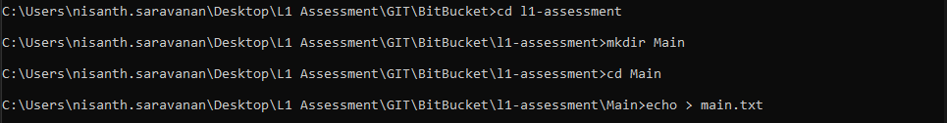

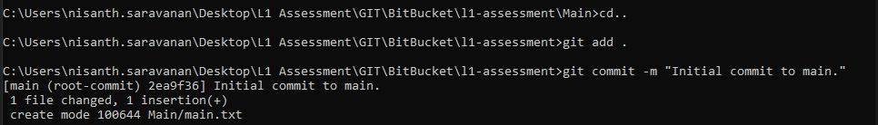

4. Pushing changes to remote:

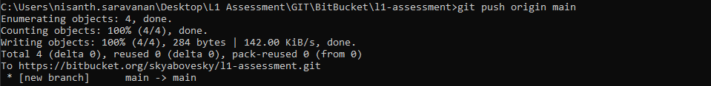

Reflection in remote:

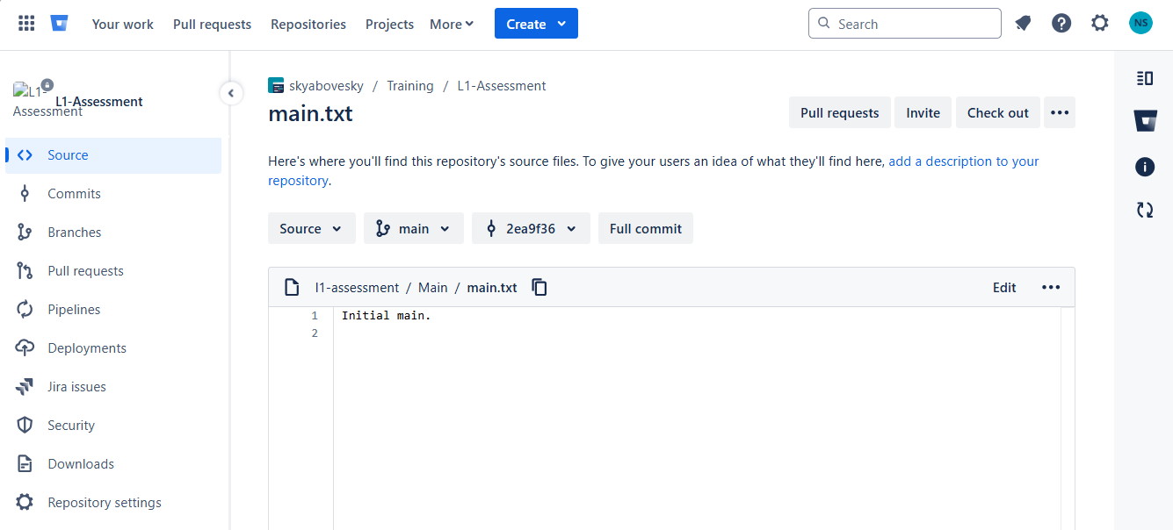

5. Pulling changes:

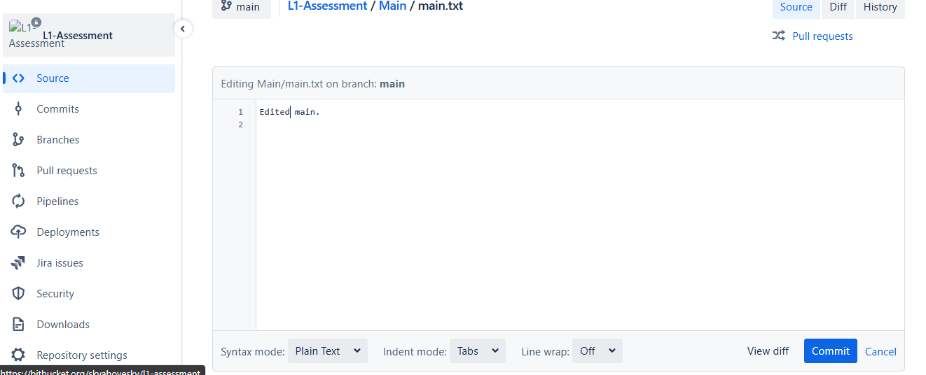

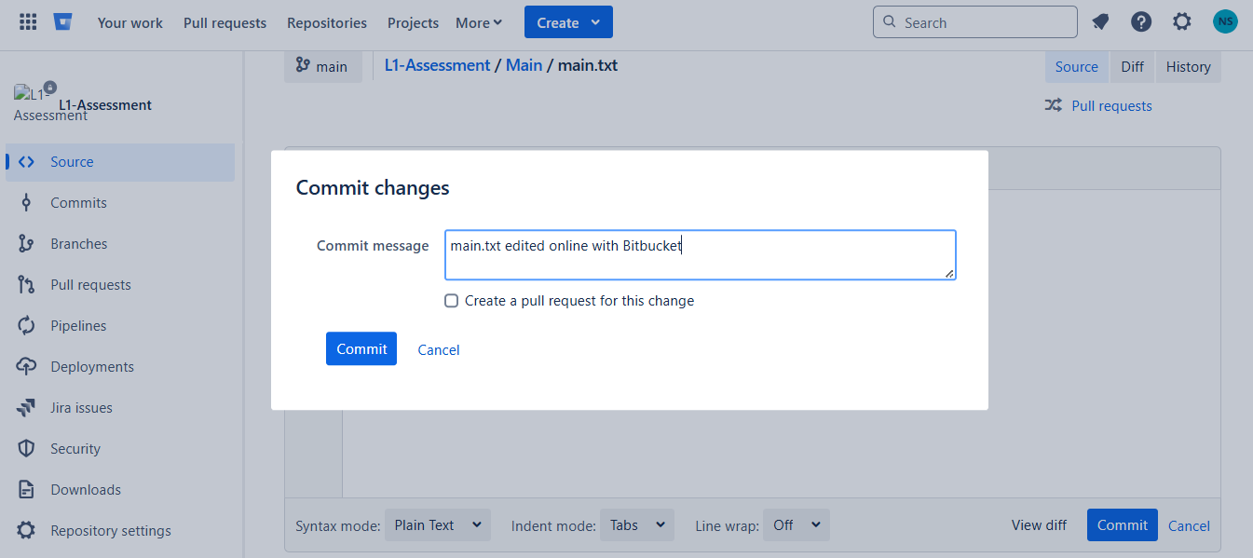
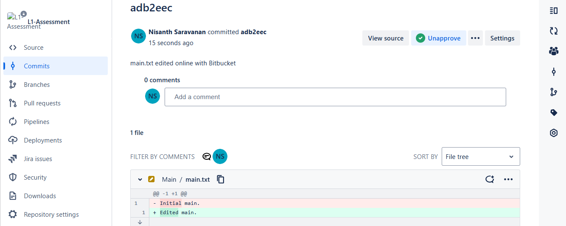

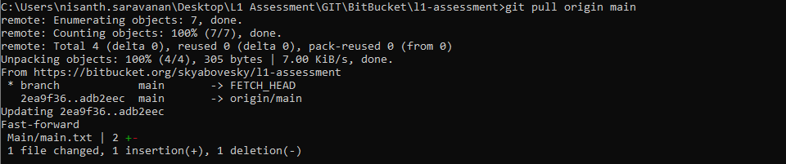

6. Branching:

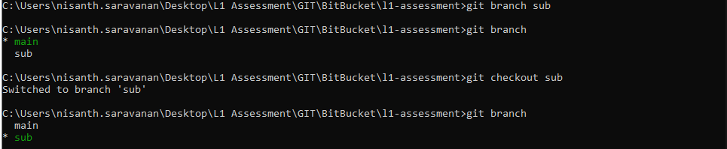

Committing and pushing to a branch:

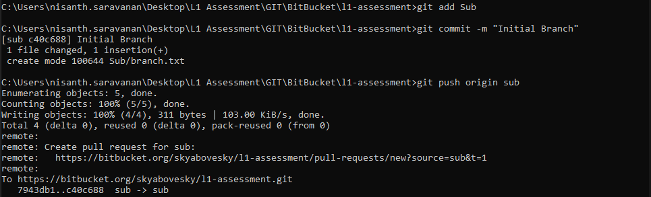

Reflection in remote:

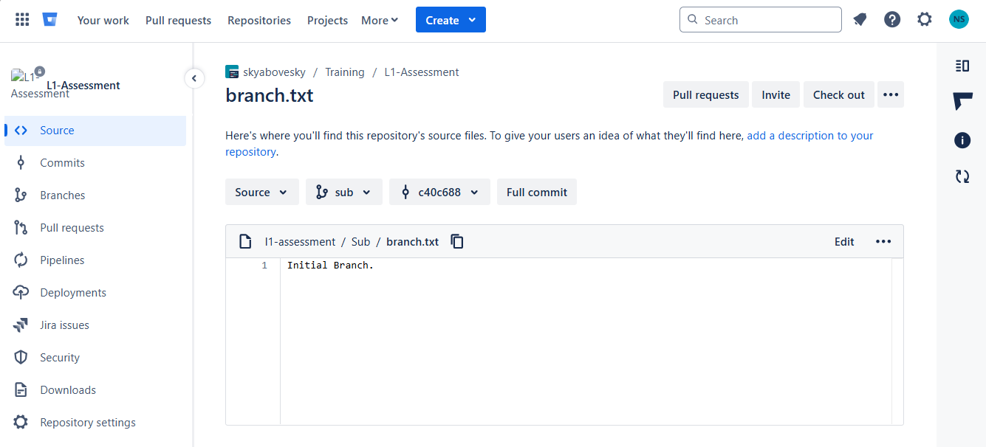

7. Conflict Resolution:

Changes in remote:

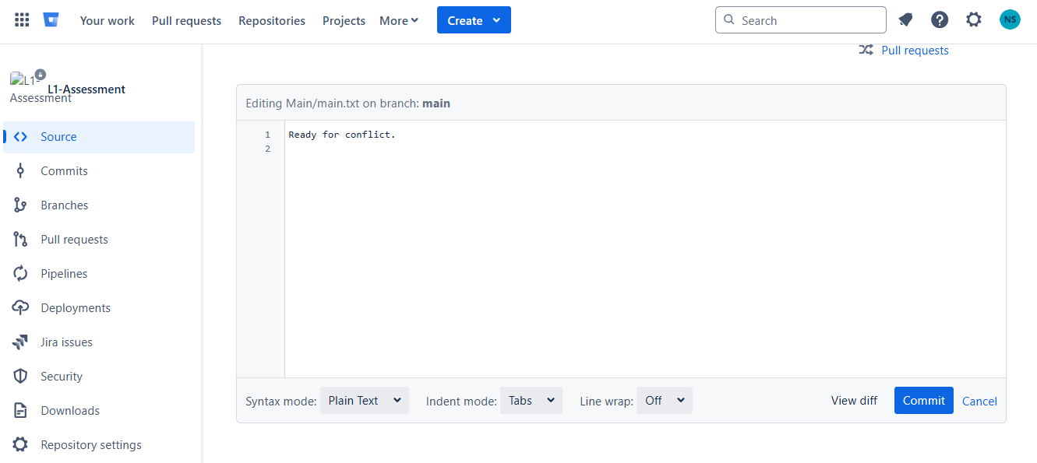
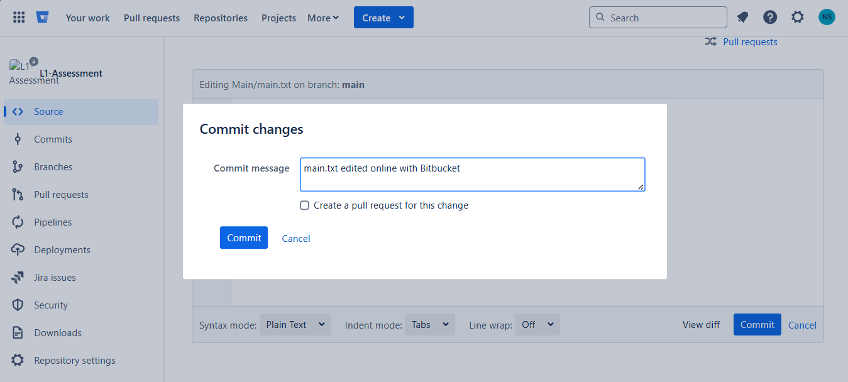

Changes in local:

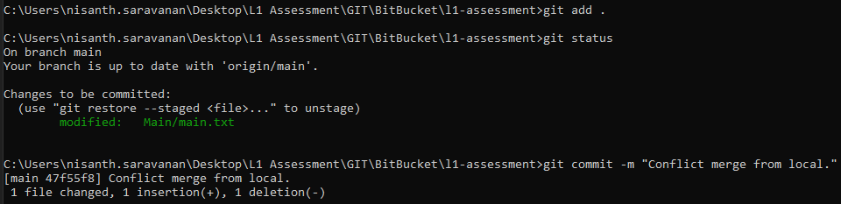

Pulling and resolution:

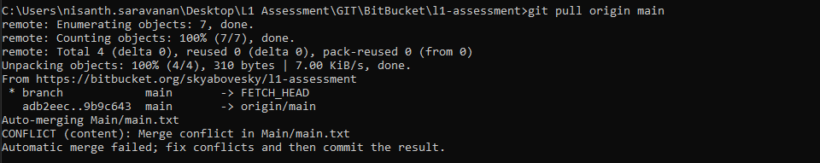

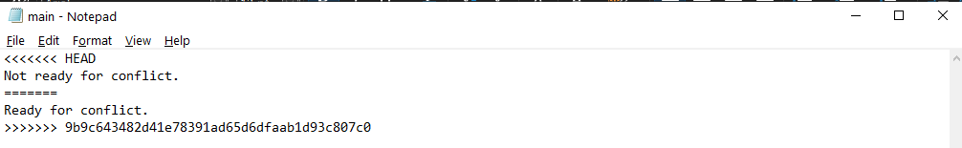

Accepting the local change, committing and pushing:

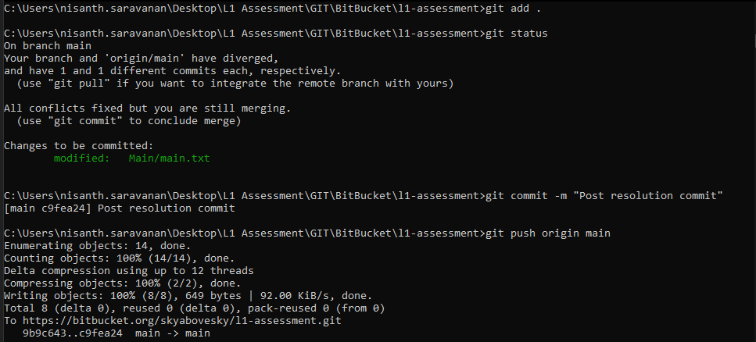

Reflection in remote:

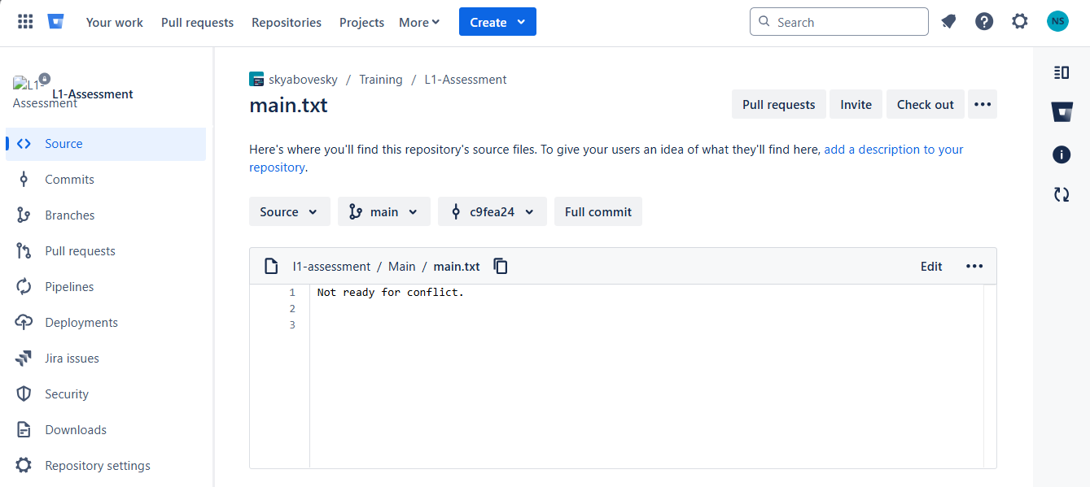

8. Pull Requests:

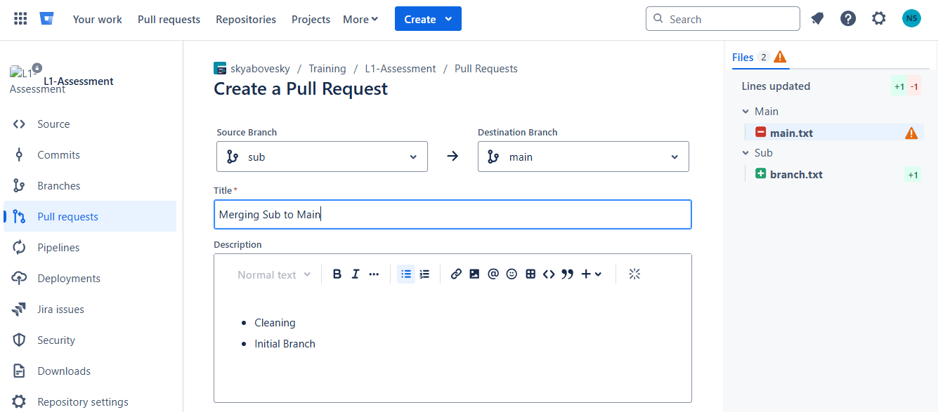

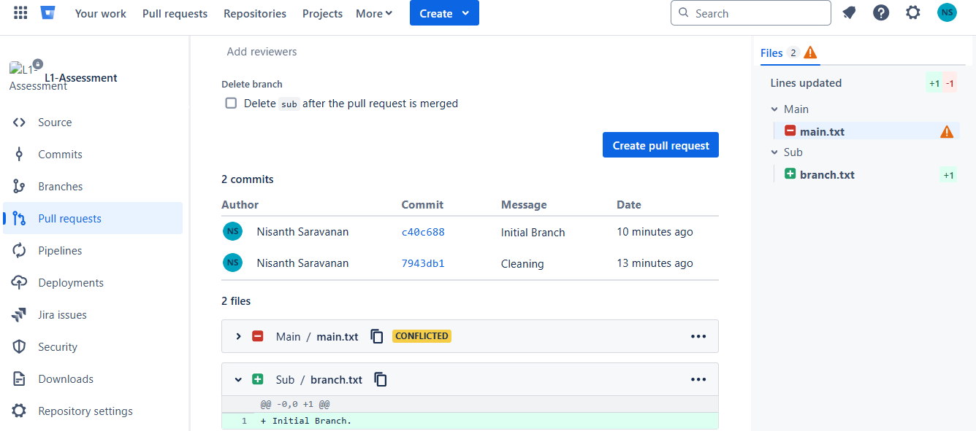

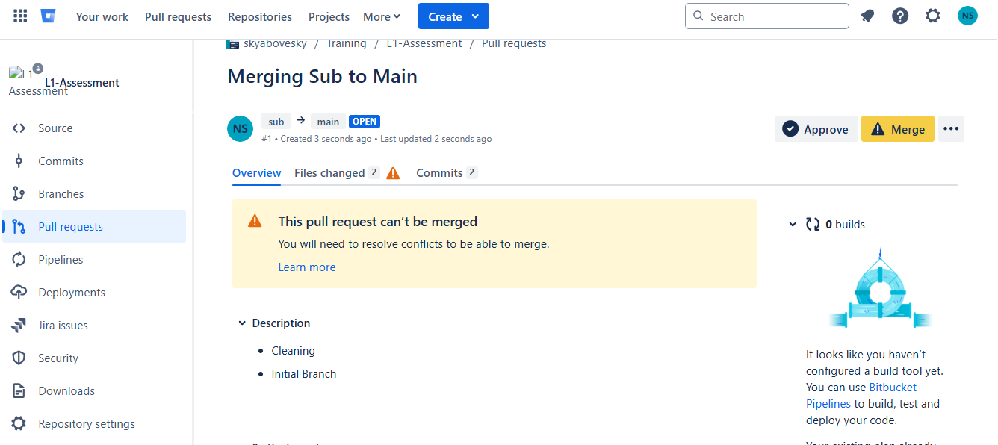

As the merging can not be done automatically, it is advised to make use of the command-line interface for merging:

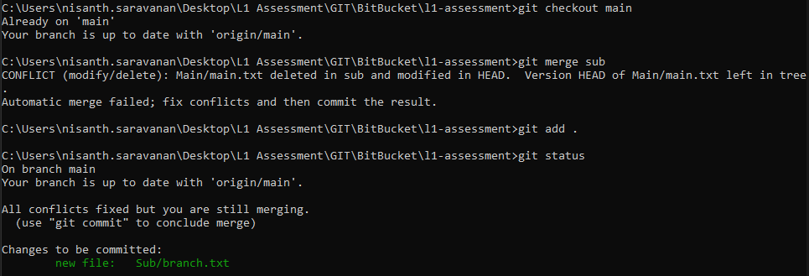

The conflict was simply a missing directory and a simple command line merge can overcome this false error and all necessary files will be reflected:

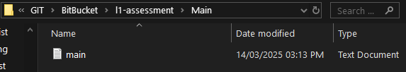

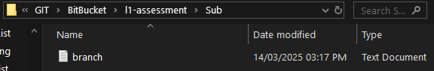

Pushing changes:

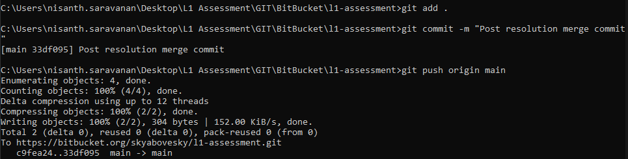

Reflection and final state of main in remote:

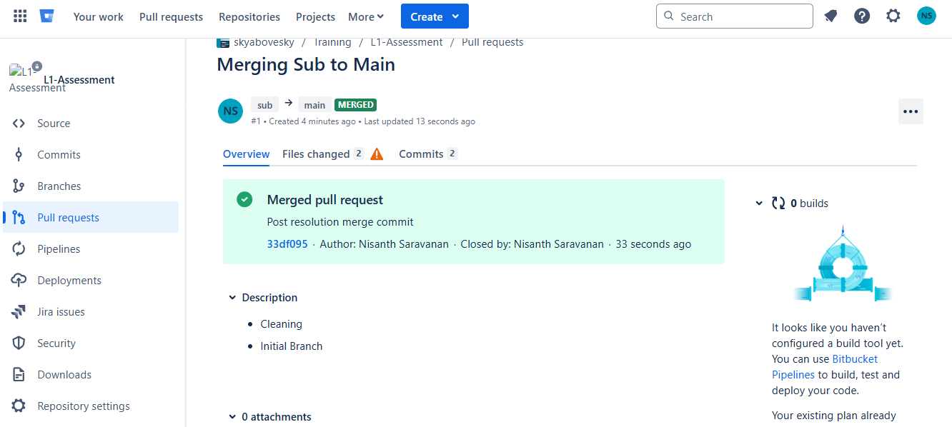

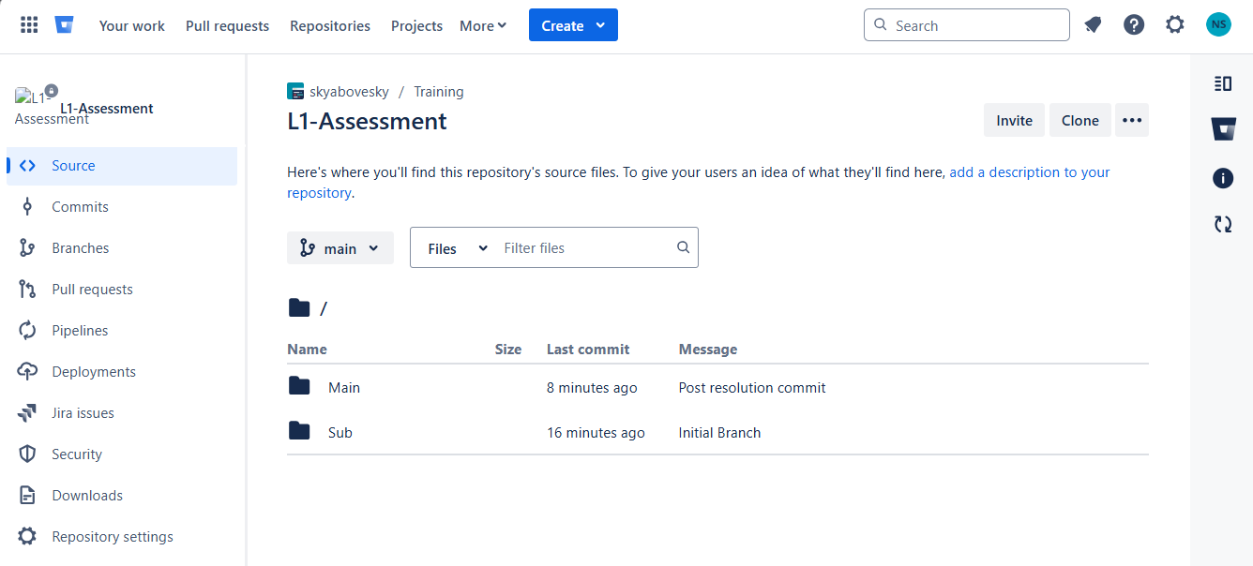

Final Reflection:

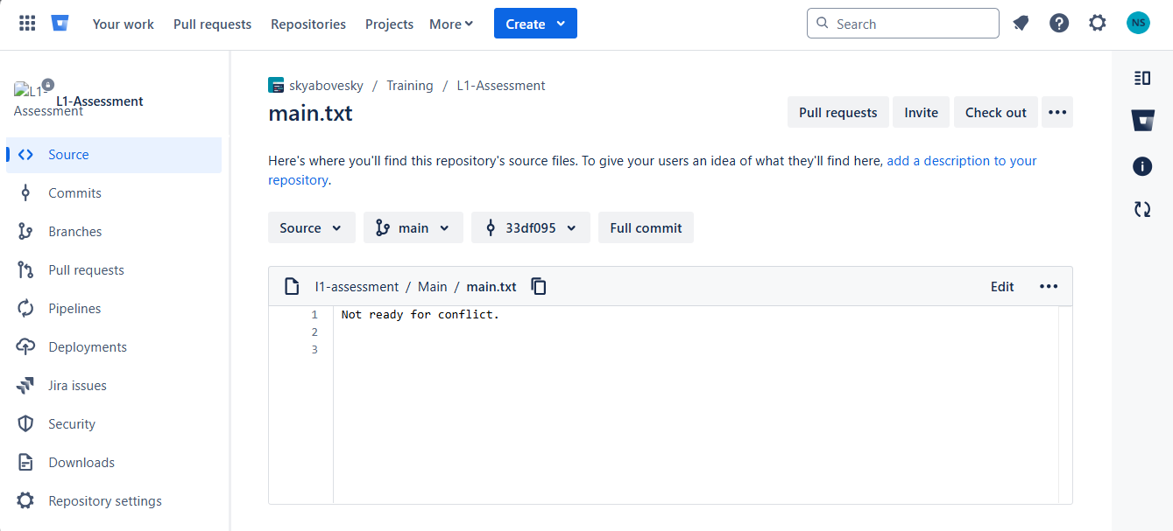

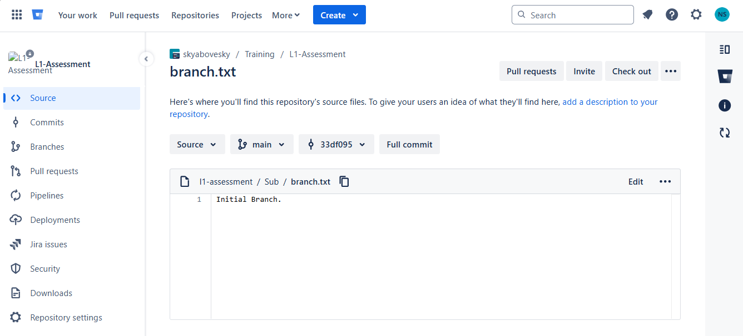

9. Deleting Branch: locally and globally:

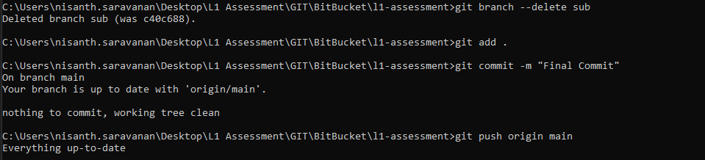

Reflection:

